 | Abdi İpekçi Caddesi Kaşıkçıoğlu Apt. No:42 D:2 34365 Nişantaşı İstanbul  www.artxist.com  info@artxist.com  T. +90 212 291 77 84 F. +90 212 343 69 35 | PRESS RELEASE

TURKISH DELIGHT
CANAN, who defines herself as an activist feminist, takes the relation between the social power structure and the body of the women as the theme of her new works; and displays them through a stunning exhibition, opening on December 22^{nd, 2011} at x-ist.

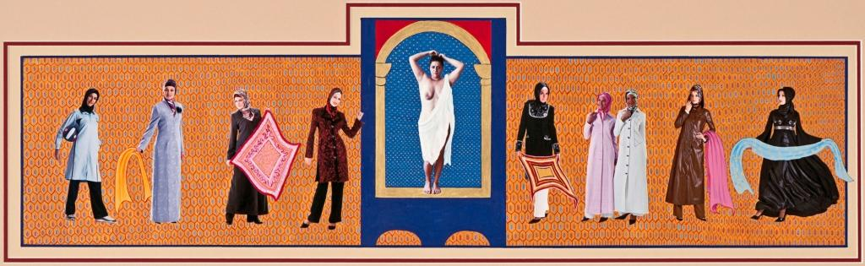

CANAN, The Veil Ceremony, ink and photography on special paper, 33 x 99 cm, 2011

During the 1990’s, the artist preferred to use a realistic language like videos, photography and documentaries, and usually described her body as a figure in the paintings. Then, she started to portray her works as miniatures that are intensive both in the visual representation and symbolism. During the same period, she also positioned herself as the “storyteller," and used collages she made from miniatures, to edit them as video animations with the approach of documentaries and sensation of fairy tales.

In this recent exhibition, we see all different types of narration styles, like realistic, symbolic and mystical/symbolic (paintings in relation with alchemy), coming together in her latest works. Furthermore, we understand that the subject in these works is both the figure of the woman, who is represented in the society and the artist herself.

The video titled “Turkish Delight” is presented at the video room with a projection and the surrounding monitors. In this video, which criticizes the oriental art and art history; the paintings that have become the symbol of the Orientalist Era are reanimated by the artist. She emphasizes the importance of art history as a visual history reading and points out the formula that Foucault mentioned in his essay about Jeremy Bentham’s Panopticon (1791), which is subjugation by means of ‘potency through transparency’ and ‘clarification’.

This is an appropriate image, particularly for the eroticized portrayal of the Muslim women, generally done by violating harem symbolically, and increasing the transparency of the walls of harem and veils. In this case, the sexual panopticism (being able to see everything) of the West, really emerges to assume power over the East, possess them through voyeurism and conquer them by striping. (Irvin Cemil Schick, “Sexual Coast of the West – Sexuality and Spatiality in Diversifying Discourse)

The artist, who dances with the music on the video that is projected, nearly stands still and poses under the camera lights during the shooting of the video that is shown on the monitors; she plays the role of oriental women figures on the painting. While portraying the woman, who was once peeped technique ‘clarification’, she keeps her body ‘under control’ all through the shooting, and edits the same work as a video, instead of a photograph. Lyrics of the song that is a part of the video are written by the artist, who answers the Orientalist perspective daringly, and recorded together with the artist group Hazavuzu.

Ansen, Kayseri, 1978

Ansen studied painting at the Mimar Sinan Faculty of Fine Arts. He has had four solo exhibitions at x-ist between 2004 and 2009, x-ist-ence, Resistance, Menace, and The Trace. He participated in The Contemporary Istanbul 06, 07, 08 and 10, artfair06 Cologne, CIGE 08 – China International Gallery

The artist, who dances with the music on the video that is projected, nearly stands still and poses under the camera lights during the shooting of the video that is shown on the monitors; she plays the role of oriental women figures on the painting. While portraying the woman, who was once peeped by using the, she keeps her body ‘under control’ all through the shooting, and edits the same work as a video, instead of a photograph.

The miniatures that are chosen by the artist with conscious precision, and their visual presentation accompanied by deep symbolism, help us as an instrument to “ease” the reading. In her works titled “Ortunme Toreni” (Veiling Ceremony) and “Avrehan”, CANAN questions the authority of the rulership mechanisms like government, religion, society and family upon the person and the body, in detail.

From the usage of frames of the paintings to the choice of color for the gallery walls, from the lyrics that accompany the oriental dance to the set up and illumination of the space, the show takes an approach that guards itself and reaches the viewer. The exhibit can be seen till January 21st, 2012 at x-ist.

Text: Esra Sarıgedik Öktem
Translation: Alp Saldamlı

CANAN İstanbul, 1970
After graduating from Marmara University, Fine Arts Faculty, CANAN won many awards and participated in residency programs in Germany and the USA. Among her exhibitions are Bashfulness (Performance, Platform Art Center, Istanbul, 2007 and Center Pompidou, Paris, 2010), Bahname (Masa Project, Istanbul, 2007), Behind the Curtains (Festival De Rode, Amsterdam, 2006), Finally in You’re in Me (İstanbul, 2000) and “New Works, New Horizons”, (İstanbul Modern Museum, İstanbul 2009). CANAN participated in Contemporary Istanbul 08 & 09, 10 and 11 and IFCA 13th International Festival of Computer Arts (Maribor), 9th International Istanbul Biennial Hospitality Zone, Scope Basel 2009, 11th International Istanbul Biennial, ART HK’10 (Hong Kong International International Art Fair) and Art Dubai 2011. She took place in the Sotheby’s 2009 and 2010, Contemporary Turkish Art Auctionsin London. In 2010, CANAN’s first solo show at x-ist Even a Cat Has a Mustache was exhibited. In 2011, she participated in the group show, ‘Dream & Reality’ at İstanbul Museum of Modern Art and ‘Where Fire Has Struck’ at Depo, Istanbul.

